Goals Workshop

2019-02-17

**2019 Goals Workshop** – Tall Poppies is a focused group of goal orientated people. We run open goal setting workshops 2x per year.   
In addition, several the team have asked Jay to run an intensive Accountability Group / Mastermind that meets fortnightly, setting goals and striving together.

## **Summary**

Attached is a summary of the workshop process that we will be conducting @ 9am sharp, on Sunday 17-02-2019. We have around 10-20 people RSVP, we will be going for a 1.5 hour walk to Kitikiti falls, and then those doing goals will stay after. We have around another 10-20 people joining in remotely.

## 

## Group concept

Tall Poppies is a group of driven goal orientated people, we run public goal sessions 2x per year.

In addition we are setting up a Tall Poppies accountability squad who will meet fortnightly (probably early morning at The Junction Eatery, as well as via video call for those overseas).

## Commitment levels

We have a range of levels of commitment and that is fine. If you want to do a low key goals, and maybe get paired up with similar level people, or an accountability coach, or with a life coach, we can set that up. Some people like to do the goals together, and then meet up in a year’s time, driving themselves works for them. Others like strict discipline or consequences (hard workout or financial penalty for not meeting goal – it depends on the person).

We cannot chase / motivate, this is about teamwork and a level of self accountability.

The Tall Poppies Accountability team is NOT recommended for those who are not highly motivated.

For this team, we have homework to work out a name, and define what we want to be covered, and the penalties / commitments. We will setup an overarching goal, and then subteams and individual goals, that work towards that mission.

Goal Workshop

## Wheel of life process

If you take the wheel below, estimate how happy you are with your current state. For example if you are in the most amazing relationship and could not think of it being any better, then for that segment, you would colour to say an 8 or 9.

This is a way to see how balanced your life is. If that was a wheel on a car, a lumpy and unbalanced life does not allow you to drive fast, so looking at the areas that you need to improve most will ensure that you are setting yourself up for success.

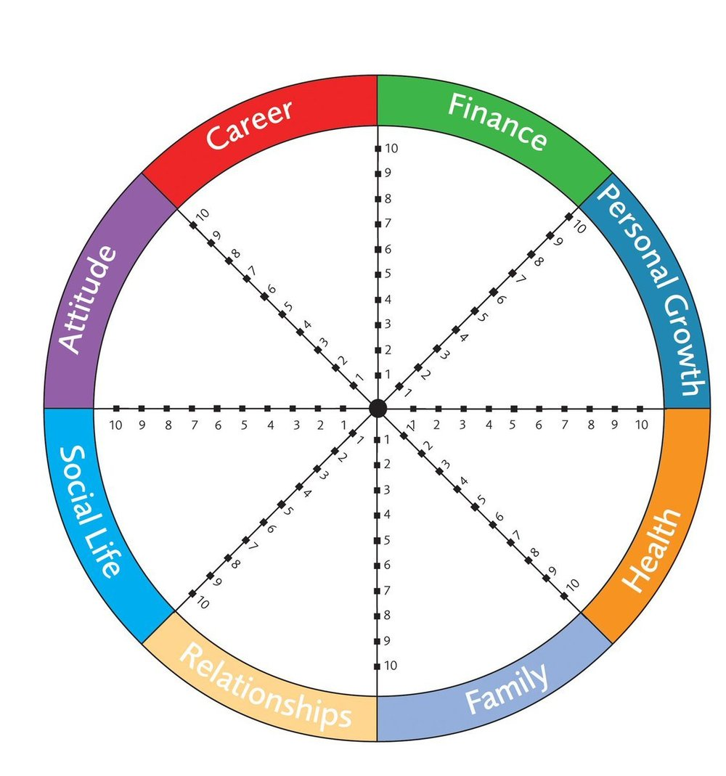

## Brainstorm mode

Be relaxed, throw lots of random ideas, nothing needs to be criticised, and whatever it is, put it down and then move onto the next idea.

When you have the list, and you have finished the brainstorming phase, you can delete the ones that you no longer like, or like least. You can highlight the timelines for specific goals, and break down the tasks that need to be actioned this year, in order to meet that long view goal. E.g. if you want to be a pilot, that may take 5 years, but this year, you need to obtain funds, and start flight training.

While you are brainstorming, think of different areas that you would love to have things in. For example:

* Finances (how much money?)
* Spirituality
* Business or career
* Investments
* Toys like boat, or car
* Tech gadgets
* Education or coaching
* Languages
* Experiences
* Holidays
* Resources / relationships
* Who do you want to be

At the back of this workbook, there is a list of the 100 most common goals (though not all of them are well defined).

Timelines – think of people you admire, what traits do you like? Also imagine your life when you are at each decade, where are you? What are you doing, what do you have, and what do you enjoy?

I find thinking of my funeral, and how people would describe me, or what my short bio might be after I am gone. David Goggins has an awesome vision of God, showing him what he achieved and how that compared to what his potential was, and being shown graphs of how little he applied himself or what he was capable of, and that this was what he is going to be ultimately judged one.

## To Do. To Don’t.

A method that Warren Buffet uses is that he looks at all the things that he could do for a goal, and then he picks just 5 MITs (Most Important Things), and that becomes his To Do. Everything else is his To Don’t. Of all the tasks that you could possibly do that would harm your ability to execute on the MITs, the second priorities present the largest risk.

Do not do the secondary tasks. You can reshuffle the priorities, and move a task from the To Do, to the To Don’t list, but having a scattered approach will mean that you are setting yourself up to fail.

Don’t be distracted. Smash the 5 MITs, then do some more.

## SMART Goals

Goals that are Specific, Measurable, Attainable, Realistic (though not always!), Time bound are the best kinds of goals

## MAP

Then set out your Massive Action Plan. Map out what you want as the end state, and the steps you need to get there. List down the next tasks that you are going to do towards that goal.

Never leave the site of setting a goal without action towards that goal. From here, immediately go and take some action towards it’s execution.

Resources

**Tall Poppies** (welcome to apply – membership includes FB group of around 200 highly motivated people, support, motivation, and a place to celebrate your wins, lots of coaches, CEOs and mentors).

**Fitness** – Katie Hacon Fitness and Mark Winter is available for PT sessions or fitness coaching

**Diet** – CSIRO or many other diet plans. Also Chris Bold has some eating plans and can help with nutrition.

**Bookclub** – we will be setting regular book club “reading” will be mainly on Audible ($14.95 / month), first book to listen to is Extreme Ownership by Jocko Willink, and Cant Hurt Me by David Goggins. This will be assigned each month.

**Accountability teams** – Can set you up with whatever motivates you best, a like minded partner to message your commitments daily or monthly, A mastermind group (Note the Tall Poppies one WILL be pretty intense), a mentor, or a paid lifecoach, or a paid Personal Trainer / Lifecoach.

We have access to 1 free lifecoaching session with one of the top Tony Robbins coaches, just let me know and I can try to get you a ticket.

**Online meetings** – if people from overseas want to be part of the Tall Poppies Accountability group, we can either have you dial in (early morning NZ time), or can share the tasks in the forum.

**Consequences** – Anyone can pledge a donation or penalty if they do not meet a goal or assign a penalty (run 10 km or something like that).



## What is Tall Poppies?

This is a collection of the most driven people we know. We set goals and provide support for each other

## What is the goal workshop?

2x per year (Jan/Feb and June each year) we have an open goal session to help people work towards goals. Joining in with the goal workshop does not need you to join Tall Poppies.

## How do I join?

To apply, you need to supply the 3 achievements that you are most proud of, and one goal that you want to achieve in your lifetime. If you get 3 votes, you are accepted in. If you do not reach the 3 votes, you are able

# The most common goals

# 

1. Blog

2. Lose weight

3. Write a book

4. Stop procrastinating

5. Fall in love

6. Be happy

7. Daily entries

8. Get a tattoo

9. Go on a road trip with no predetermined destination

10. Get married

11. Travel the world

12. Drink more water

13. See the Northern Lights

14. Learn Spanish

15. Save money

16. Take more pictures

17. Kiss in the rain

18. Buy a house

19. Make new friends

20. Learn to play the guitar

21. Run a marathon

22. Learn French

23. Get a job

24. Get out of debt

25. Read more books

26. Be more confident

27. Write a novel

28. To live instead of exist

29. Skydive

30. Eat healthier

31. Exercise regularly

32. Learn Japanese

33. Get in shape

34. Learn to cook

35. Start my own business

36. Quit smoking

37. Travel

38. Read more

39. Visit all 50 states

40. Learn sign language

41. Swim with dolphins

42. Learn to play the piano

43. Learn to surf

44. Have better posture

45. Go skydiving

46. Identify 100 things that make me happy (besides money)

47. Lose 20 pounds

48. Wake up when my alarm clock goes off

49. Stop biting my nails

50. Decide what the hell I would like to do with the rest of my life

51. Learn to dance

52. Make a difference

53. Learn to drive

54. Become financially independent

55. Learn Italian

56. Get organized

57. Lose 10 pounds

58. Be a better friend

59. Have a baby

60. Graduate from college

61. Visit Japan

62. Create my own website

63. Exercise more

64. Live passionately

65. Lose 30 pounds

66. Volunteer

67. Make more friends

68. Learn German

69. Spend less time fooling around on the net and more time actually working

70. Be more social

71. Travel around the world

72. Write a song

73. Love myself

74. Get my driver's license

75. Backpack through Europe

76. Learn to play guitar

77. Design my own tattoo

78. Meditate daily

79. Go on a cruise

80. Worry less

81. Stop caring what other people think of me

82. Go to college

83. Get more sleep

84. Learn how to drive stick shift

85. Meet new people

86. Practice yoga

87. Learn another language

88. Create my own tattoo

89. Design my own clothes

90. Sleep under the stars

91. Send a message in a bottle

92. Learn to sew

93. Never stop learning

94. Win the lottery

95. Finish what I start

96. Get a dog

97. Be a better person

98. Bungee jump

99. Figure out what I want to do with my life

100. Grow my hair long